TASKS ON KEY MANAGEMENT SERVICES (AWS KMS)
Task 1:
Create a Customer Managed Key (CMK)
- Create a symmetric CMK.
- Enable key rotation.
Implementation:
Create a Symmetric CMK Using AWS Console
Step 1: Open AWS KMS
- Log in to AWS Console
- Search for KMS
- Click Key Management Service (KMS)
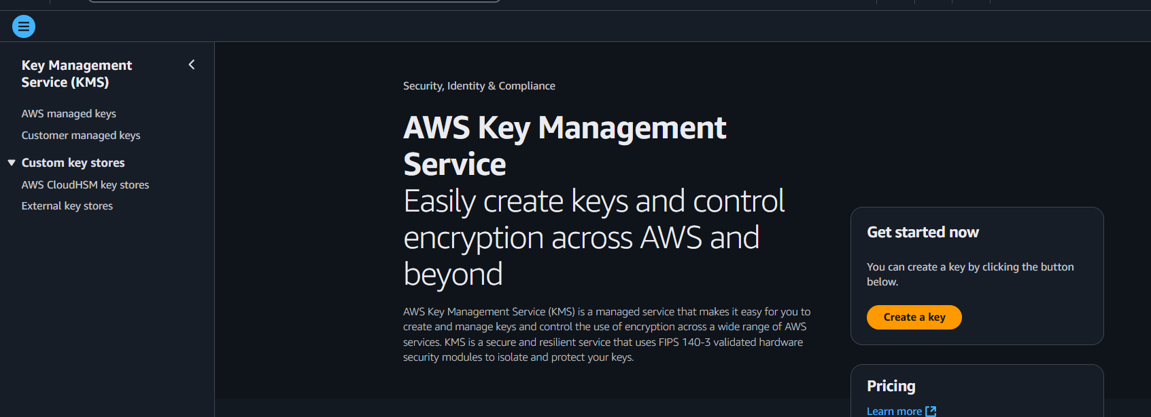
Step 2: Start Creating a Key
- Click Customer managed keys
- Click Create key
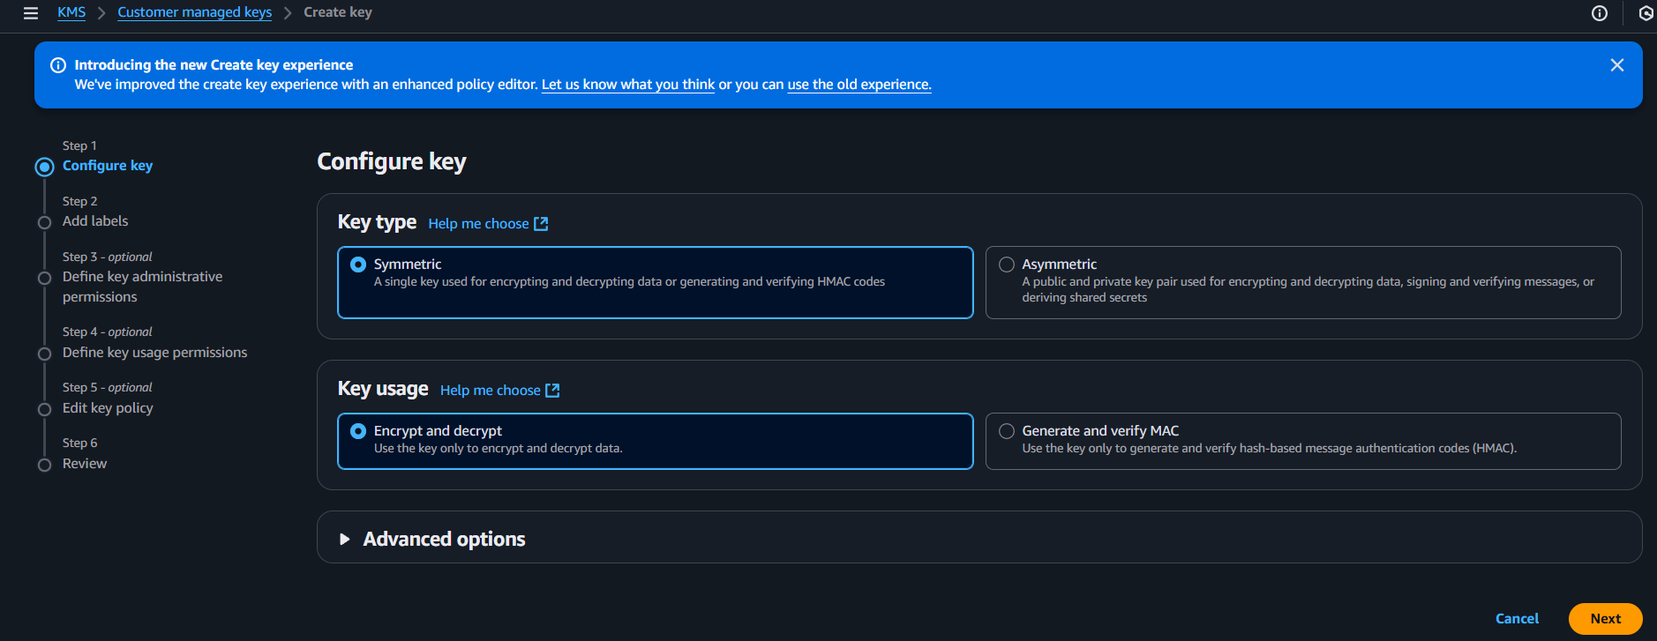
Step 3: Choose Key Type & Usage
- Key type → Select Symmetric
- Key usage → Select Encrypt and decrypt and click on next
Alias: e.g., alias/app-data-key.
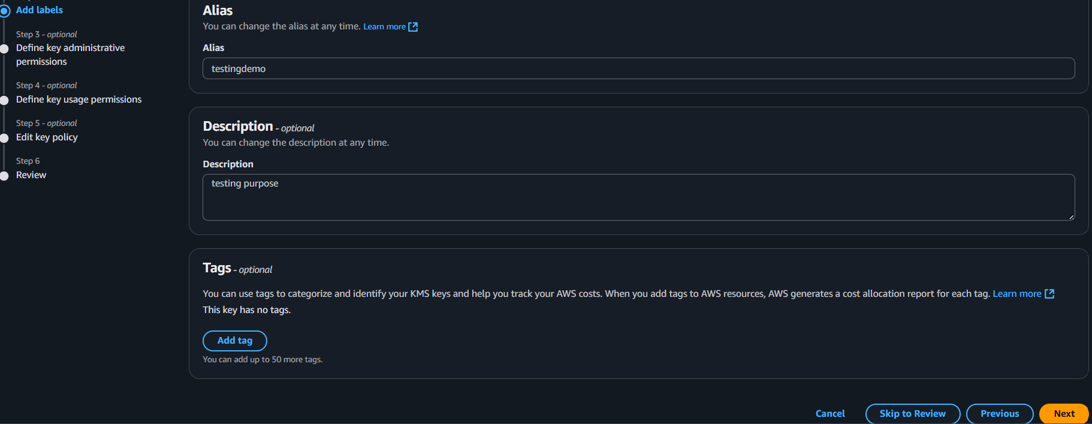
Key administrators: Add IAM principals who can manage the key (security/admin group).
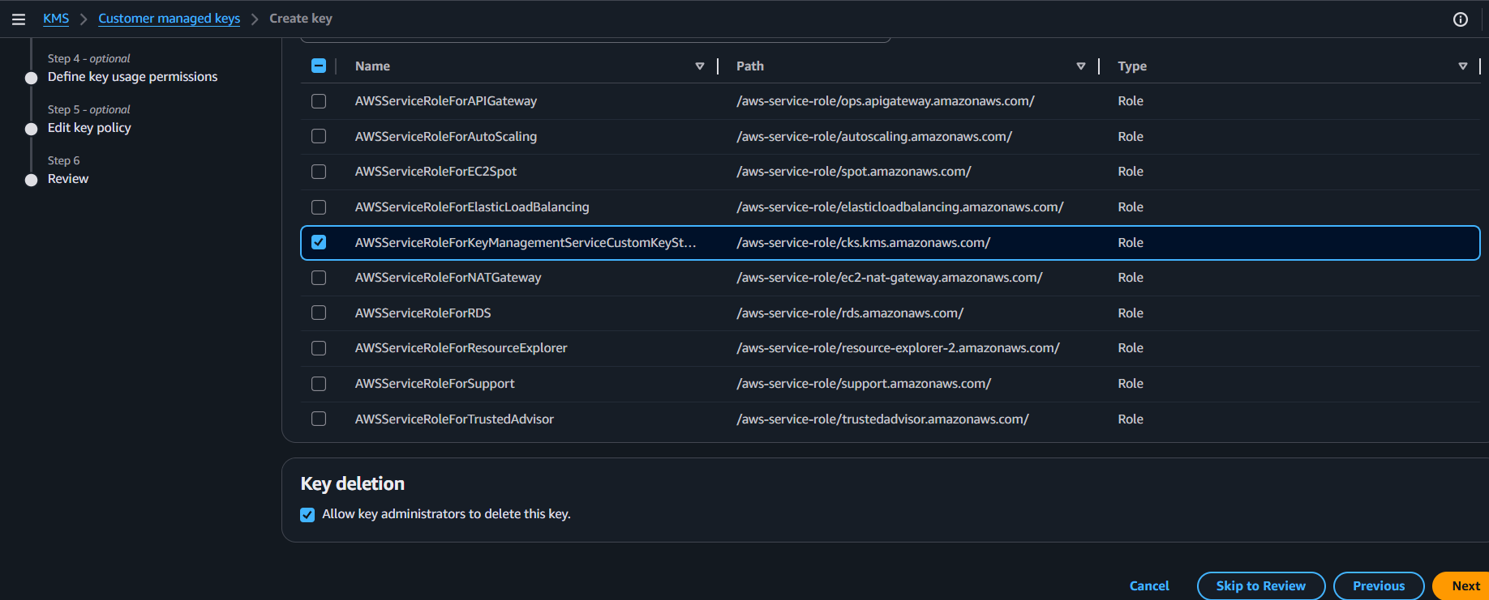
- Finish: Review and create.
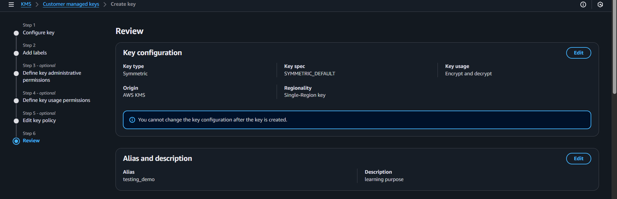
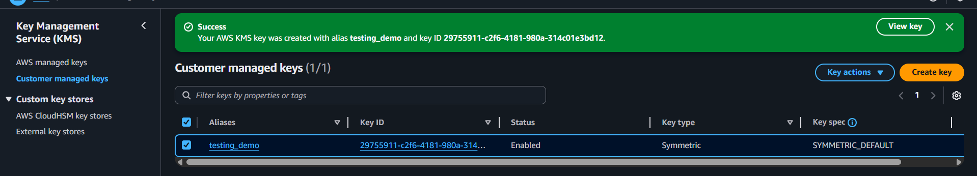
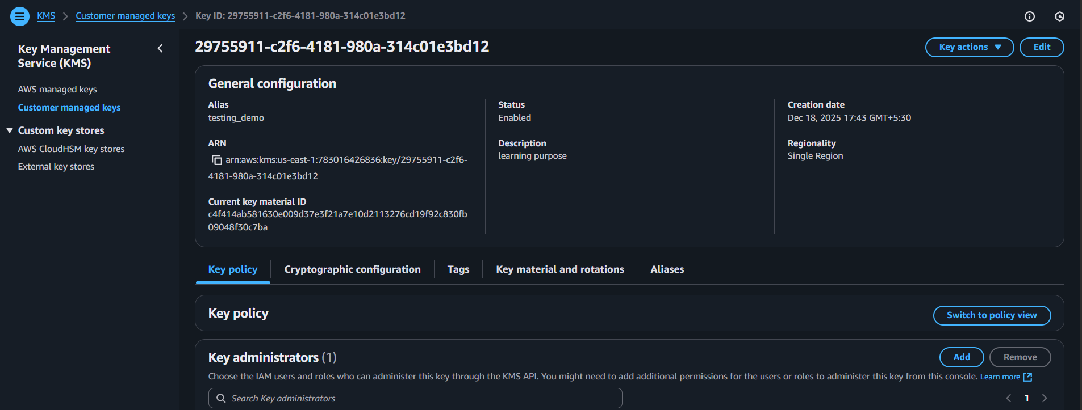
Enable key rotation
- Open key details: KMS > Customer managed keys > your key.
- Rotation: Enable automatic annual rotation (AWS rotates the backing material once per year).
- Save: Confirm rotation is enabled.
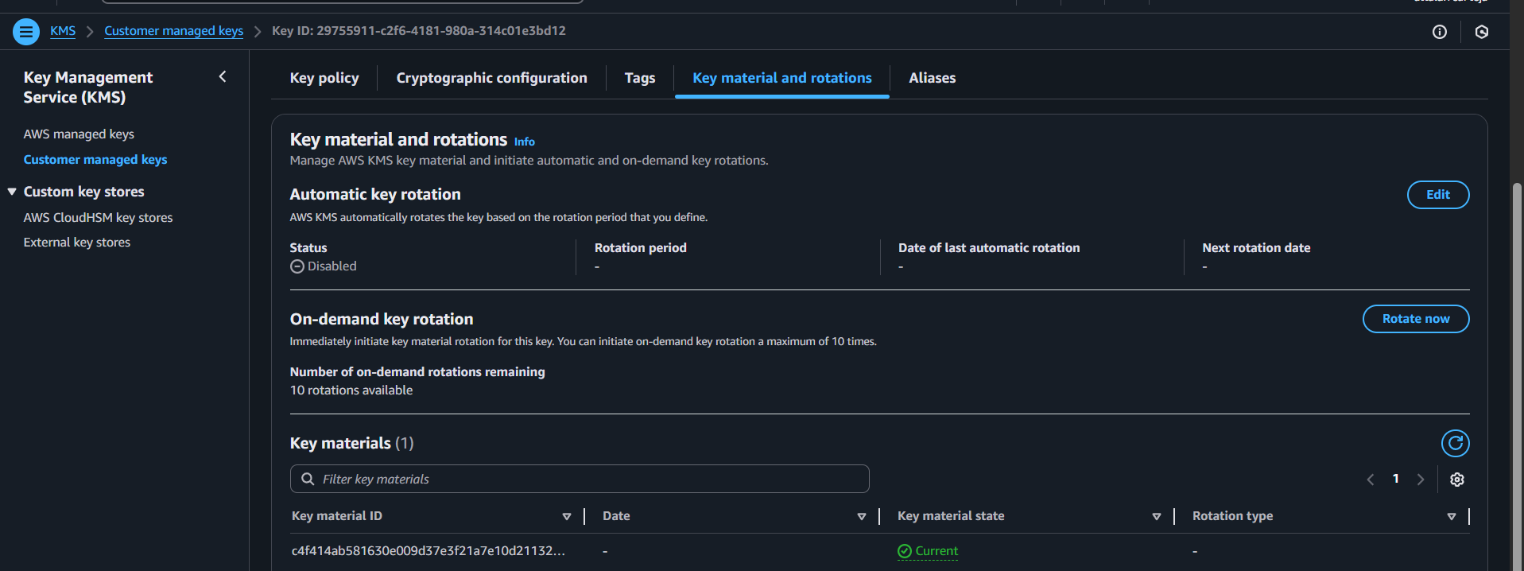
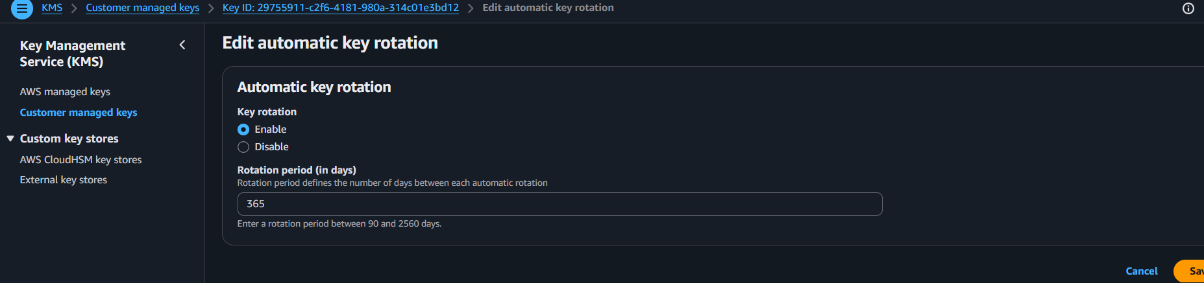
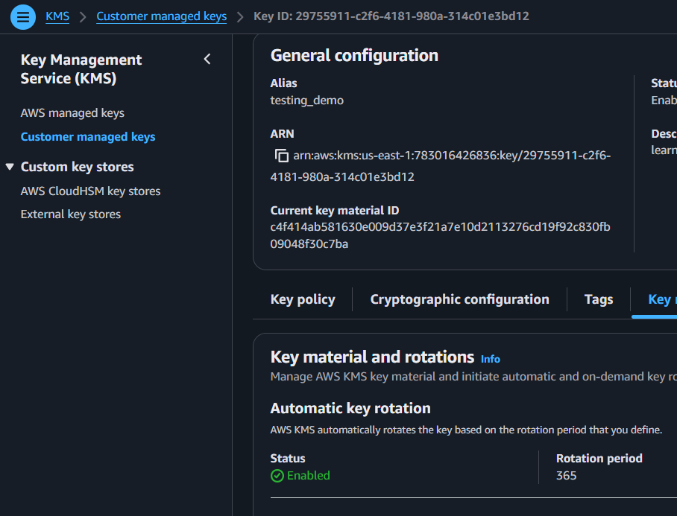
Created a bucket and edited the default encryption to kms
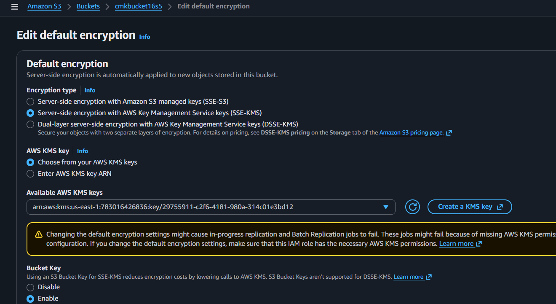

Add the IAM user in kms key administrations and users
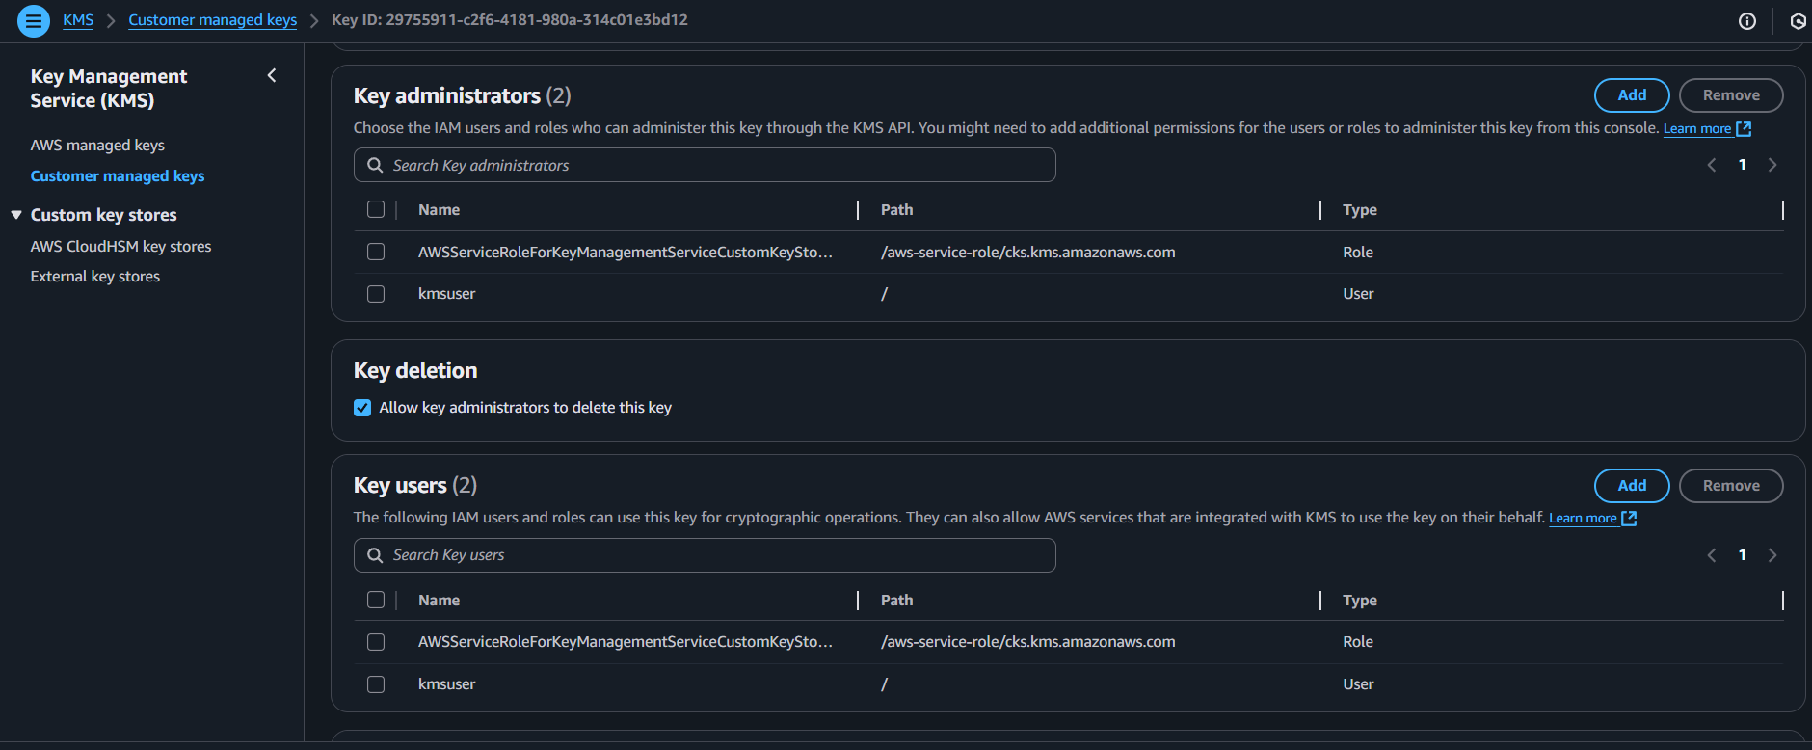
Verifying with added IAM user
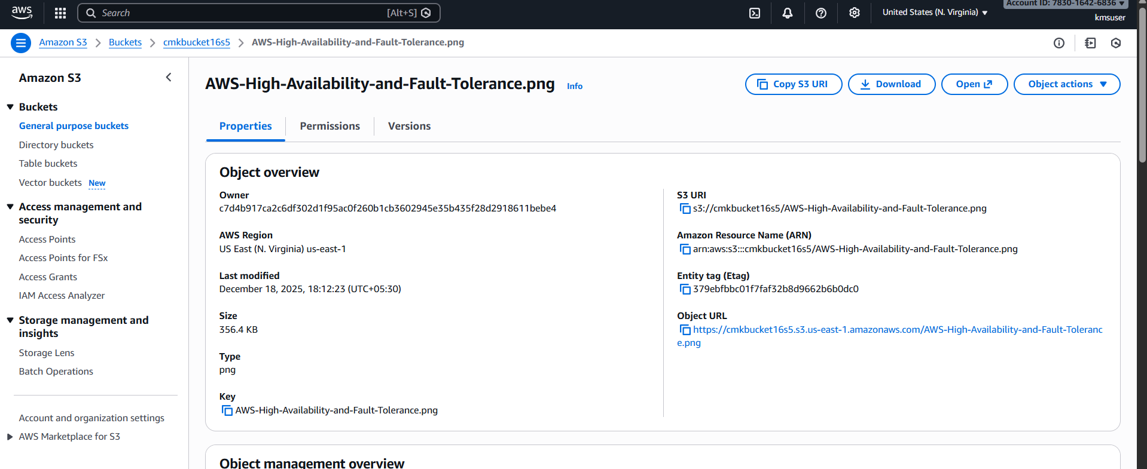

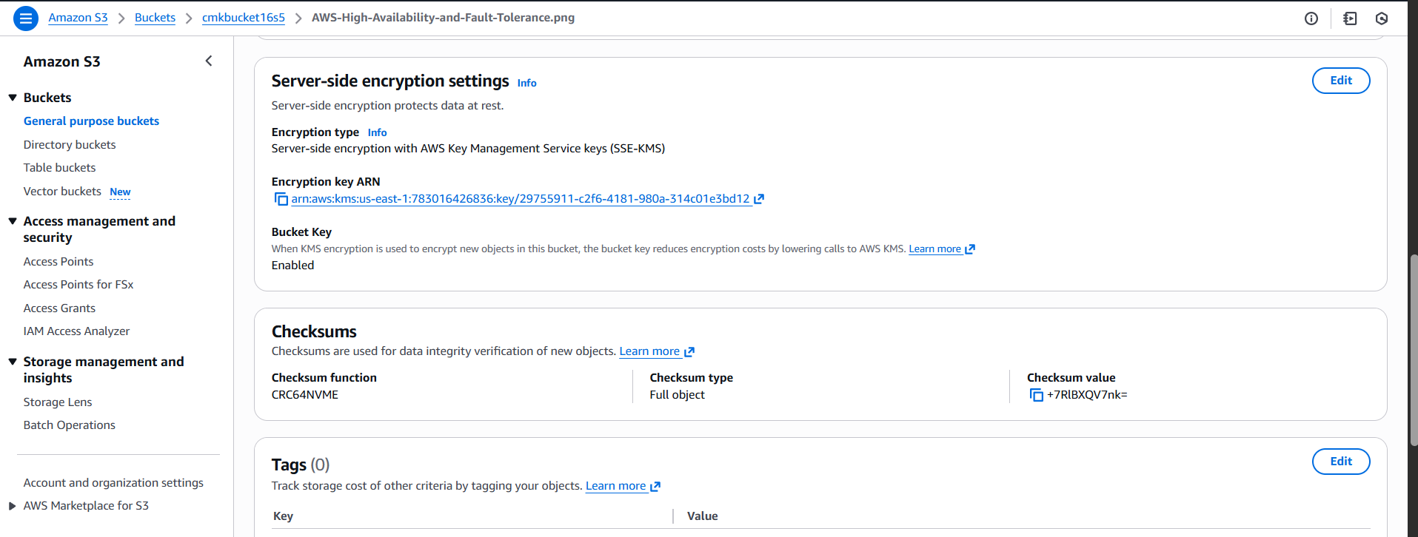

The user accessed the image
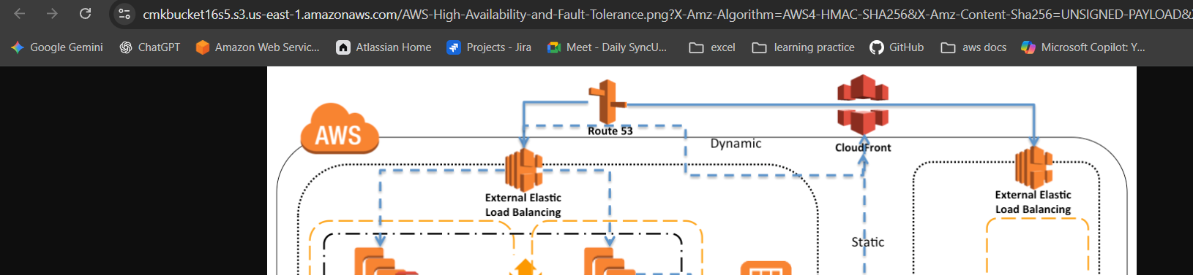
Again verifying with iam user for him I didn’t added in kms administartion and users
So that he could not able to view or download the object
